**Angeles  City Science High School**

**Science 9**

**Name:** Paul Gerald D. Pare **Section:** 9 - Adenine

## ACTIVITY 1: FIND MY MATCH

Match the following terms to their definitions. Write your answers on the space provide.

LUSTROUS DUCTILE MALLEABLE HARDNESS

THERMAL CONDUCTIVITY ELECTRICAL CONDUCTIVITY

Lustrous All metals are shiny when polished or freshly cut

Electrical Conductivity All metals conduct electricity

Ductile Metals can be drawn into wires

Hardness Metals have resistance to scratching or abrasion

Malleable Metals can be hammered into sheets and able to reshaped or flattened.

## ACTIVITY 2: SHOW IT!

1. Draw a diagram to show what will happen to the layers of metal ions when the metal is hit with a great force with a hammer.

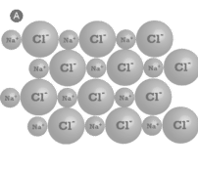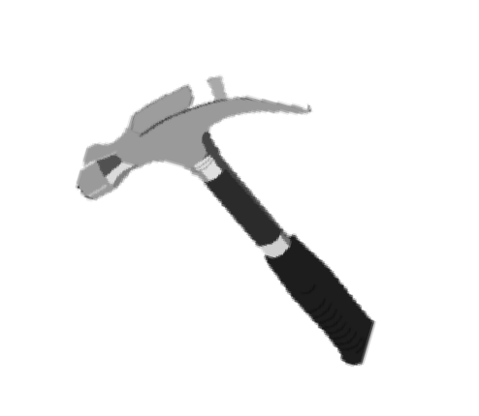

1. Explain your diagram using the terms: metallic bonding, atomic structure, delocalized electrons and malleability of metals.

## The atomic structure of metals are compact because they are solids. The metallic bonding or simply as the sharing of free electrons among a structure of positively charged ions. It is in the form of an electron cloud of delocalized electrons. One of the properties of metals is malleability, meaning they can be hammered into sheets and still be able to reshaped.

## ACTIVITY 3: FILL ME!

Fill in the gaps in the following text using the words in the box below.

metallic bonds

delocalized

localized

sea of electrons

regular

atoms

losing

Metals are giant structures of sea of electrons. In pure metals, the atoms are arranged in a regular lattice structure and in tightly packed layers. Metals have a regular arrangement of positive ions surrounded by atoms. Electrons have been lost from the metal atoms and are delocalized. This means that they can move freely through the atomic structure of the metal. As a result of losing electrons, the metal atoms become attracted to the sea of electrons. The particles in a metal are thus held together by strong metallic bonds and a lot of energy is needed to separate the particles.

## ACTIVITY 4

MULTIPLE CHOICE. Choose the correct answer. Write your answers on the space provided.

D 1. Which one of the following substances is NOT ductile?

A. Copper B. Gold C. Silver D. Water

C 2. What do we mean when we say a metal is ductile?

1. It is very dense. C. It can be stretched into thin a wire.
2. It is a good conductor of heat. D. It can be beaten into different shapes.

D 3. Most metals are malleable. What does this mean?

1. They have high melting points. C. It can be stretched into thin a wire.
2. They are good conductors of heat. D. It can be beaten into different shapes.

D 4. Which property of metals that can be beaten I to thin sheets

1. Conduction C. Lustrous
2. Ductility D. Malleability

B 5. Which one of the following is a good conductor of electricity?

A. Glass B. Iron C. Plastic D.Wood

C 6. Which of the following statements are correct?

1. All metals are ductile C.Generally, metals are ductile
2. All non-metals are ductile D. some metals are ductile

A 7. Which one of the following CAN'Tbe drawn into wires?

A. Coal B. Iron C.Copper D. Aluminum

C 8. What would be the best way to determine if an element is malleable or not?

1. see if it conducts electricity C. try to hammer it flat
2. see if it sinks or float D. shine a light on it

C 9. Which of the following have the ability to carry electricity?

1. Thermal Conductivity C. Electrical Conductivity
2. Ductile D. Malleable

B 10. What do metals conduct?

1. Electricity C. Heat
2. Both D. Neither

## ACTIVITY 5: COMPLETE ME

Complete the Venn diagram. Use the words below as your reference.

Share Electrons

Loss/Gained Electrons

Form Compounds

CO2

NaCl

## IONIC BONDS COVALENT BONDS

Form Compounds

Shared Electrons

CO2

NaCl

Loss/Gained Electrons



ACTIVITY 6:

Ionic Bond between a Metal and Non-Metal (**M + NM**)

Covalent Bond between a Non-Metal and Non-Metal (**NM + NM**)

DIRECTIONS.Determine if the elements in the following compounds are metals or non- metals. Describe the type of bonding that occurs in the compound.

|  |  |  |  |
| --- | --- | --- | --- |
| **COMPOUND** | **Element 1**  **(metal or non- metal)** | **Element 2 (metal or non-metal)** | **Bond Type** |
| NO2 | N= non metal | O= non metal | Covalent |
| SO2 | S= non metal | O= non metal | Covalent |
| CO2 | C= non metal | O= non metal | Covalent |
| CaO | Ca= metal | O= non metal | Ionic |
| H2O | H= non metal | O= non metal | Covalent |
| CuCl2 | Cu= metal | Cl= non metal | Ionic |
| Rb2S | Rb= metal | S= non metal | Ionic |
| HF | H= non metal | F= non metal | Covalent |
| CCl4 | C= non metal | Cl= non metal | Covalent |
| AlF3 | Al= metal | F= non metal | Ionic |
| NBr3 | N= non metal | Br= non metal | Covalent |

## ACTIVITY 7

Based on the characteristics of ionic and covalent bonds, determine if the following is a compound (ionic bond) or a molecule (covalent bond).

1. The substance has a very high melting point and can conduct electricity well.

The substance is a compound because it has characteristics of an ionic bond.

1. The substance will shatter into uneven pieces when dropped.

The substance is a molecule because it has characteristics of a covalent bond.

1. When broken, the substance will break in straight lines along the bonds in the crystal lattice.

The substance is a compound because it has characteristics of an ionic bond.

1. The substance is a gas a room temperature and has a very low boiling point.

The substance is a molecule because it has characteristics of a covalent bond.

1. The substance can be reshaped when heated making it very ductile

The substance is a compound because it has characteristics of an ionic bond.